Smithycroft Secondary School
Standards & Quality Report
Session 2024 – 2025

This summary report is provided for parents/carers and partners to outline our achievements and improvements during session 2024 - 2025 and to share our improvement priorities for 2025 - 2026. Throughout last session we took forward our improvement priorities as detailed in our school improvement plan. Using our approaches to self-evaluation, we have detailed in this report the impact of our work and identified how we plan to continue to improve outcomes for our children and young people.

The context of the school
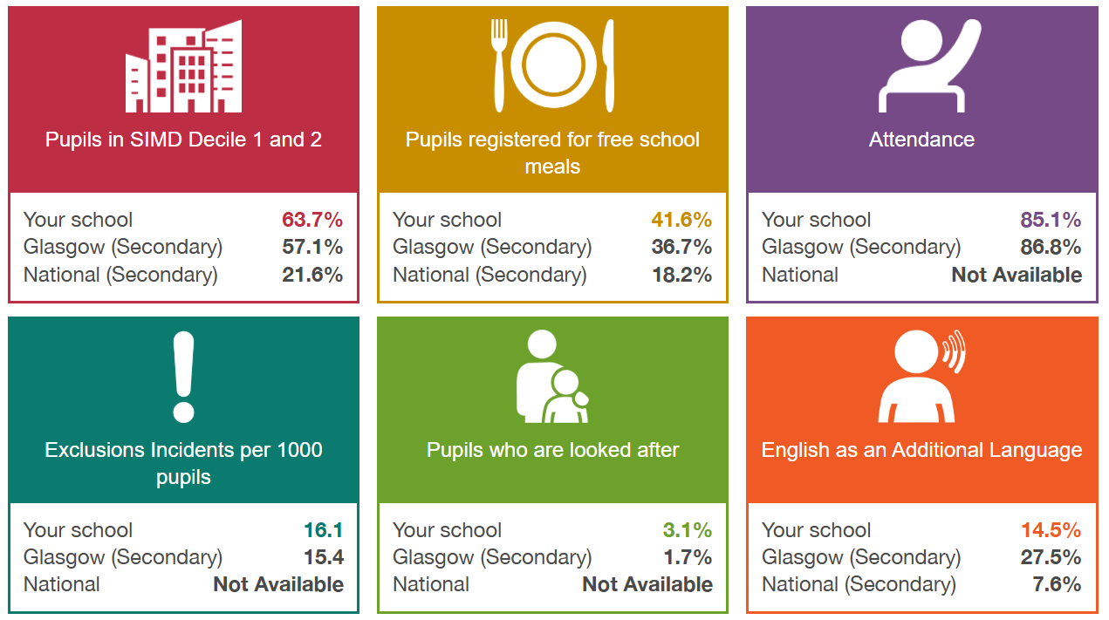

Our achievements and improvements 2024 – 2025
Key developments (leadership of change) (QI 1.3)
- We continued our clear focus on improving learning with our internal collegiate calendar focused on our Learning and Teaching strategy,

- We undertook significant year-long consultation across the whole school community - partners, young people, staff, parents - to revise our school vision and values, culminating in the launch of our new values at the end of session 2024-25. We have clear plans to embed them in the coming session.

- We continue to offer significant professional learning for staff to gain leadership experience through our associate programmes at Middle and Senior level. This has resulted in several staff successful moving into Senior roles both in Smithycroft and beyond.

- We undertook significant consultation around our journey to improve learning and teaching, including focus groups of all teaching staff following our Collaborative Improvement Visit in March 2025

Developments in learning, teaching and assessment (Q1 2.3)

- Staff worked in a combination of professional learning teams to improve practice across the 5 key elements of out learning strategy
- Cross currlcula teams chose a specific Key Element that they wanted to work on embedding in their practice. They carried out sprints and gathered data on impact which was received and collated by our Learning and Teaching team. Additional professional reading was provided to support each sprint.
- Department teams chose a specific Key Element that they wanted to work on embedding in their practice within their departments. They carried out sprints and gathered data on impact which was received and collated by PT L&T. Additional professional reading was provided to support each sprint.
- Consultation was carried out with regards to developing a L&T QA calendar. A L&T QA process and calendar was agreed on, which departments embedding within their departmental self-evaluation processes.
- Our Collaborative improvement visit in March 2025 noted that:
‘There were major strengths in the learning environment, classroom atmosphere and ethos. There was an overwhelmingly positive and calm consistent environment for young people to learn. Strong nurturing relationships were evident, as were strong routines built into classroom practice. Young people were ready to learn and respectful. Most teachers have an understanding of the school’s vision for Learning and Teaching’

Progress in promoting well-being equality and inclusion (QI 3.1)

- Attendance Matters Strategy - Our 4 step strategic approach to increasing attendance by improving existing practices in conjunction with the introduction of new innovative approaches has improved outcomes for our learners.

- Early Identification & Prevention – Using a data led approach we extracted data weekly, prioritised and applied interventions amongst the year teams to drive improvement. Our new digitised late line strategy saw an immediate 40% reduction in daily group calls for absence

- Attendance Statistics - Our headline attendance figure has improved by 4.8% - this is against a backdrop of decreasing attendance nationally. Our school attendance increase is the biggest of all 30 Glasgow Secondaries. To that end, our approach is having a direct impact on young people and what they can achieve every single day, improving outcomes for them and their families.

- Sharing Best Practice - Education Scotland published a case study and podcast on success of our attendance strategy, in particular how our Parent Council supported this priority.

Case Study: https://education.gov.scot/resources/attendance-matters-at-smithycroft-secondary-school-glasgow-city-council/
Podcast (Staff): https://www.youtube.com/watch?v=7eGwEikFEZg
Podcast (Pupil): https://www.youtube.com/watch?v=LebO4_PS_uk

- We have used Pupil Equity Funding (PEF) to target improvements in the Health and Wellbeing of all young people through our partners at FARE and Jn 12.

- This continued focus has enabled us to offer a significantly enhanced service with mental health support groups for parents and young people and trained Mental Health ambassadors to support the student body. We now have support groups for targeted young people - from anger management to Emotional Literacy - running every week in school. This includes support from our Campus Officer at Police Scotland

- We have embedded Mental Health and Well-being and Leadership into the curriculum in S3 and S4 with young people studying for Level 5 qualifications

- We continue to support young people every day through our Breakfast Club provision.

- We have made significant progress on Pupil Leadership and developing the role of young people in leading improvement in our school. We now have clear structures to support systemic listening with young people at every level.

- We use Glasgow’s Motivational and Wellbeing profile to track the impact of interventions.

Progress in children’s learning /raising attainment and recognising achievement (QI 3.2)
In the Broad General Education

- Almost all young people in S3 are attaining at expected levels in Literacy and Numeracy. The Majority are attaining at Level 4, beyond national expectations.

In the Senior Phase

- An increased number of young people in across the senior school are achieving qualifications at Level 4, 5 and 6 and in Literacy and Numeracy. We have seen steady increases in this measure and now our young people are significantly outperforming young people nationally with similar characteristics

- For example, 66% of young people in S4 attain at least a Level 5 in both Literacy and Numeracy. This is more than double the % (31) four years ago and is the direct result of targeted improvement. The picture is similar in S6 and also good in S5.

- Attainment for young people across the curriculum has improved in all senior year groups this year. For example, those in S4 attaining at least one Level 5 qualification has improved again to 73%.

- Those attaining 5 or more at level 5 is up 8% in the last four years and is now on a par with the Glasgow figure (35%).

- Those attaining at least 3 level 6 qualification in S5 is up 9% to 29%. 26% of S6 attained at least one level 7 qualification – the equivalent of Advanced Higher. This is twice as many as young people nationally with similar characteristics

- Our highest attaining young people in S4 outperformed similar young people across the country. This is the 4th year in the last 5 that this has been the case.

We have used Secondary Improvement Funding (Scottish Attainment Challenge) resources to offer both universal and Targeted Supported Study classes. This includes an extended programme of Supported Study, Academic Comeback, Saturday School, two residential study weekends and Easter School

Wider Achievement:
- We further increased the number of young people completing Saltire Awards both through our Community Award curriculum, in S5/6 and other volunteering opportunities.
- We continue to have a significant number of young people working in ambassadorial roles, principally as Sports Leaders in the community but increasing in the Arts and STEM fields.

Attendance and Exclusion data
Our headline attendance figure in 2024-25 was 85.1%
Exclusions continue to be in line with the Glasgow average

Our improvement plan priorities 2025 – 2026
Our new Grand Challenges for 2025-26 and beyond are:

- What is young people’s experience of learning in classrooms?

and

- How well are they attaining?

What is young people’s experience of learning in classrooms?

Our strategic priorities under this challenge include:

- Implementing the Smithycroft Lesson Cycle to ensure a consistently ‘Very Good’ experience for young people

- Developing a whole staff collegiate calendar to support implementation of lesson cycle

- Developing strategies to ensure that young people are involved in approaches to improving learning and are active in evaluating their impact.

- Exploring further ways to embed the five key elements of our learning strategy into the Smithycroft Lesson Cycle

How well are young people attaining?

- Establishing and tracking subject by subject attainment baselines in the Senior Phase to ensure that all young people are attaining as well as they can.

- Further embedding the whole school Self-Evaluation calendar in order that all staff are involved in revieing and evaluating the quality of our work.

- Reviewing our approaches to tracking and assessment in the Broad General Education to ensure that there is challenge for every young person.

 | How Good Is Our School 4 Quality Indicator (QI) | Evaluation
 | Leadership of Change (QI 1.3) | Good
 | Learning Teaching and Assessment (QI 2.3) | Good
 | Ensuring Wellbeing Equality and Inclusion (QI 3.1) | Good
 | Raising Attainment and Achievement (QI 3.2) | Good

How to find out more about our school
Contact us directly if you require further information about our school or if you wish to comment on this report.

Our contact e-mail address is: headteacher@smithycroft-sec.glasgow.sch.uk

Our telephone number is:0141 5820220

Our school address is:

Further information is also available on our website www.smithycroft-sec.glasgow.sch.uk

