Measuring Electricity Level E Homework Sheet 1

Name_____________________________________________________________

- For each circuit write down if it is a series or parallel circuit.
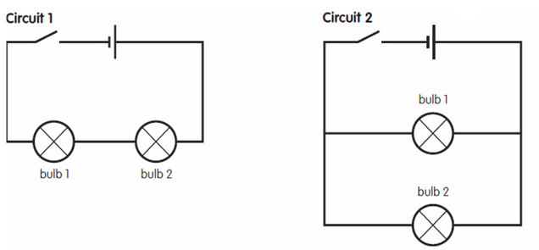

___________________________ _________________________

- What will happen if bulb 2 was unscrewed in each of these circuits?

________________________________________________________________

________________________________________________________________

________________________________________________________________

3.


Copy circuit 2 and add a switch which will turn on and off bulb 1 only.

