Electricity Revision

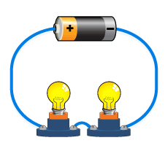

- Draw the following as circuit diagrams.
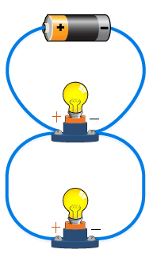
a) b)

- From the diagrams in question 1 say which of the circuits is parallel and which is a series circuit.
________________________________________________________________________________________________________

- What is the difference between series and parallel circuits?
____________________________________________________________________________________________________________________________________________________________

- What is voltage?
____________________________________________________

- What is current?
____________________________________________________

- What is electricity?
____________________________________________________

- What piece of equipment do you need to measure voltage? ________________________________________________________

- What piece of equipment do you need to measure current?
_________________________________________________________

