Smithycroft Secondary
Science

Problem Solving

Energy

Problem Solving – Energy

- The label shows there are two types of fat in the margarine.
500g Net Weight
Energy 30.4 kJ per gram of fat
130 grams of saturated fat
270 grams of unsaturated fat
100 grams of water
Margarine
Tub
Label

(a) What percentage of the margarine is saturated fat? (2)

(b) How much energy is stored in the fat in the margarine? (2)

- The table shows how much of the world’s energy was obtained from different sources in 1989.

Source | Energy obtained (%)
Soild fuel  Nuclear fuel  Hydro-electric  Natural Gas  Liquid fuel | 30  4  8  23  35

Construct a bar graph to show the information given in the table (3)

- Peanuts and sugar produce heat when they are burned.
Claire wanted to find out if peanuts produced more heat than sugar. She set light to the peanuts. The heat given out was used to heat water and the temperature rise of the water was recorded.

She then repeated the experiment using the sugar.

State two things she must keep the same for this to be a fair test.
(2)

- The amount of energy an electrical appliance uses can be calculated using the formula:

E = P x t

Where E = Energy in kilowatt hours (kWh)
P = Power of the appliance in kilowatts (kW)
t = time in hours

A 2 kilowatt electric fire used 12 kilowatt hours of electrical energy. How long was the fire switched on for? (2)

- Some pupils carried out a survey of heating in their neighbourhood.

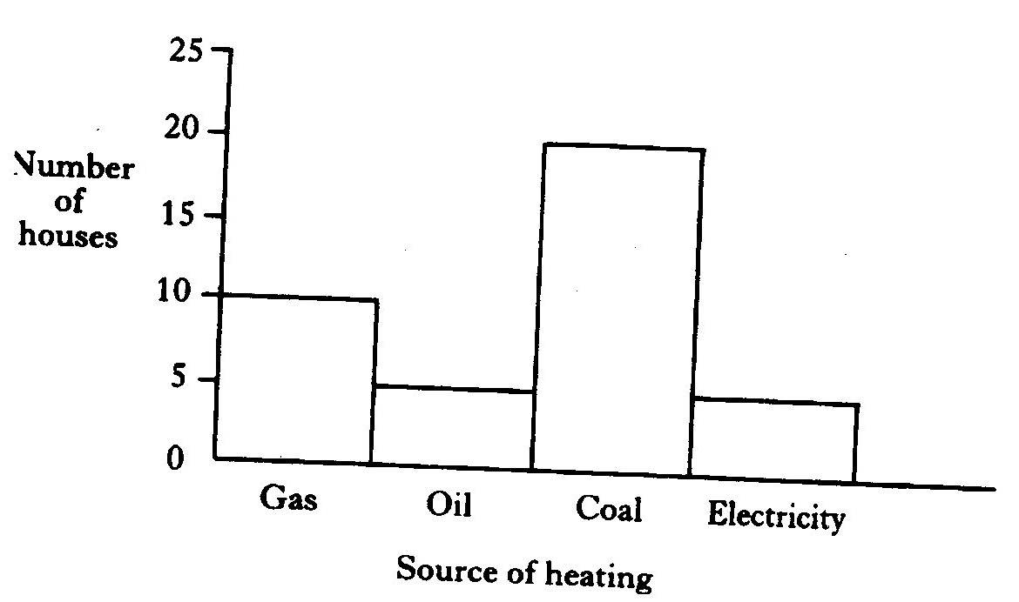

]

Here are the results.

(a) How many houses were surveyed? (1)

- Which of the following pie charts shows the same results as the bar graph?
