**Optics Revision**

1. How does light travel?
2. What are the two types of lenses that we have used
3. How do you make a rainbow in the lab?
4. What colours does white light get split up into?
5. Show on the diagram below how the light passes through the lens.

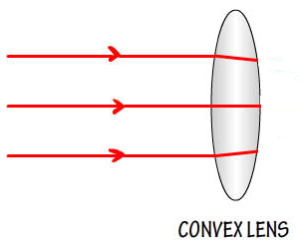

1. List all the parts of the electromagnetic spectrum.