**Forces Revision**

1. Here is a picture of the Earth orbited by a satellite and with an approaching meteor heading straight for it!. Label the direction the Earth's gravity is acting in on both of them.

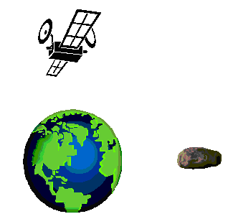

2) Here is a picture of the Moon being orbited by the shuttle and an alien spaceship coming to land. Label the direction the moon's gravity is acting in on both of them.

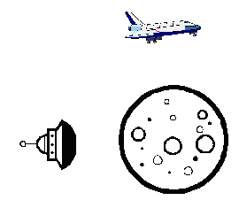

1. Write down the weights of these lumps of clay as shown on these Newton balances.

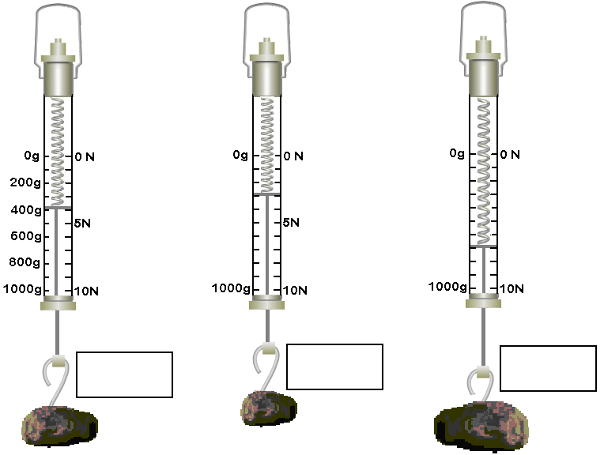

1. Gravity on Earth gives **1kg of mass, a weight of about 10 Newtons**. On the Moon, gravity gives **1kg of mass only 2 Newtons** of weight. Finish this table to show the mass and weight on the moon and Earth.

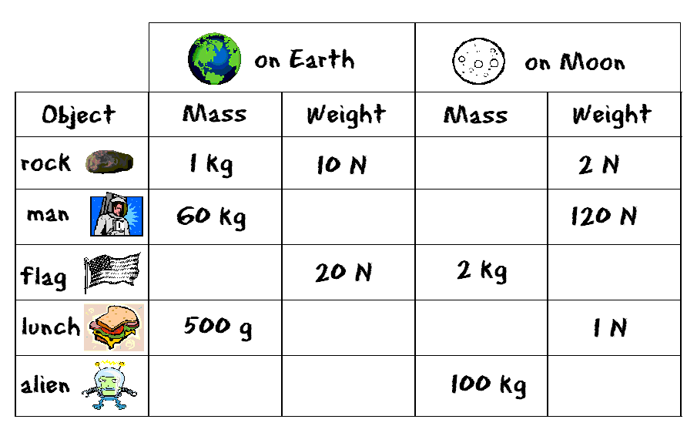

1. a) Jim did the same experiment with a different elastic band. He drew a graph of his results. Here is the graph.

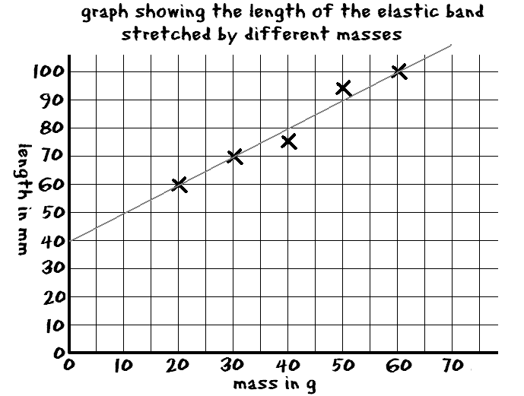

b) What length was the band when Jim used 30g to stretch it?

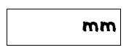

c) What was the length of the unstretched elastic band?



1. John dropped a heavy 1 kg mass and a lighter tennis ball from the atrium balcony. In which order did they hit the floor?

The 1kg mass first the ball first same time

1. Jan did the same thing with the tennis ball and a **flat** piece of paper. In which order did they hit the floor?

The paper first the tennis ball first At the same time

1. a) How could Jan change the paper so that both the tennis ball and the paper hit the floor at the same time?

b) Explain why this would make both hit the floor at the same time