Smithycroft Secondary Science

Problem Solving

Energy
Problem Solving – Energy

- Two litres of water were boiled in an electric kettle.
The graph shows how the water temperature changed with time after kettle was switched on.
The kettle was switched off after 3 minutes.
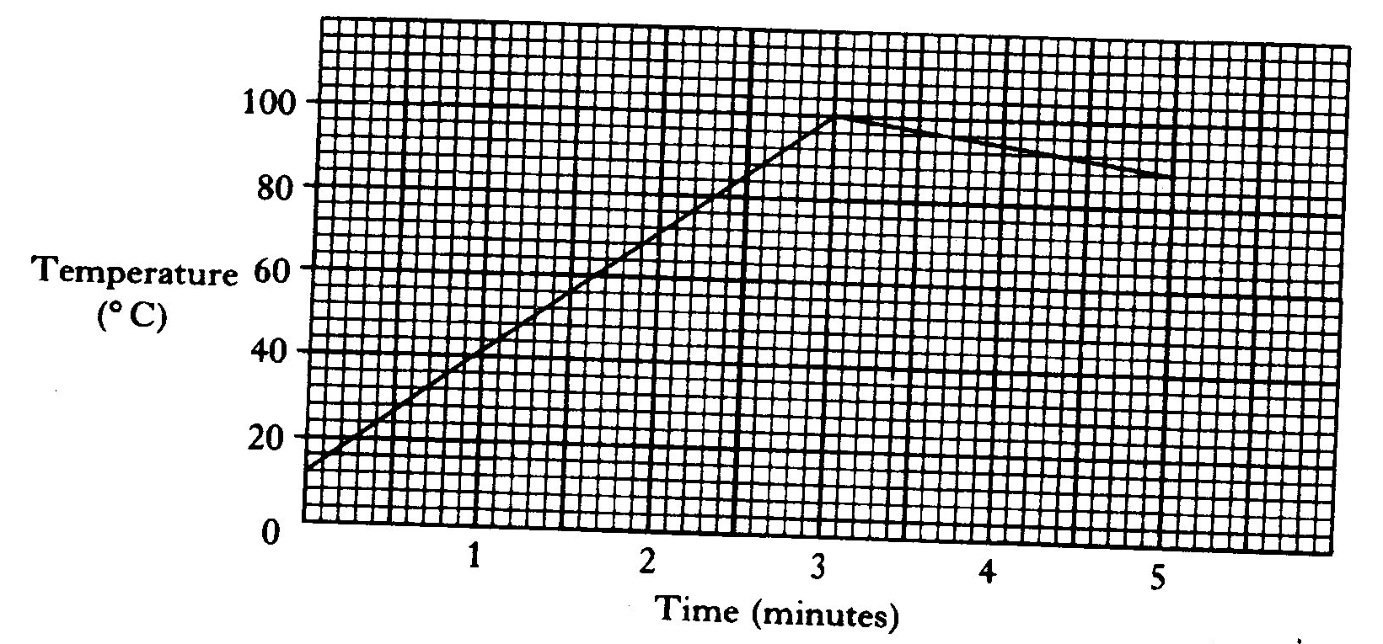

(a) What was the temperature of the tap water used to fill the kettle? (1)

(b) Explain the shape of the graph. (2)

- The graph below shows the main yearly doses received by members of the public in Britain.
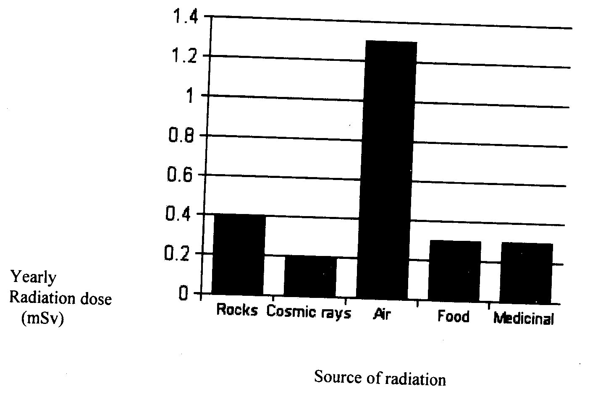

What percentage of the total does comes from food? (2)
- Storage heaters use cheap electricity during the night to heat storage blocks.
These blocks release heat during the day when electricity costs more.

The table shows information about four materials which could be used to make storage blocks.

Material | Heat released when a 1 kg block cools by 1°C | Mass of a 1 cm block | Cost of a 1kg block
Concrete | 1350J | 2.5g | £2.50
Copper | 400J | 8.9g | £24.00
Fireclay | 1600J | 3.5g | £2.00
Marble | 1400J | 2.6g | £3.15

- Give two reasons why copper is the worst material for making storage blocks? (2)

- List the remaining three materials in order, with the best material for making storage blocks first. (1)

- Explain your reasons for choosing the first material in your list. (2)

