**Cells Revision**

1. Copy and complete the following sentences using the word bank below to help you.

Clearly, lenses small, cells, structure, magnification

a) All living things are made up of basic units called _________________. A cell is the simplest ____________ that can exist on its own. Cells are very ___________ and cannot be seen with the naked eye.

b) A microscope contains _______________ that are used to make cells look larger. This increase in size is called ___________________.

Stains can also be used to help show up cell structures more _______________. (3)

2. Label all the parts of the diagram below and then complete the table. (3)

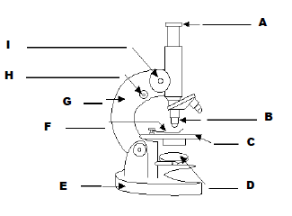

|  |  |  |
| --- | --- | --- |
| **Letter** | **Name of Part** | **What it Does** |
| I |  | Gets a sharp picture |
|  | Slide clip |  |
| B | Objective Lens |  |
| A |  | Magnifies |
|  | Mirror |  |

3. a) Write two rules that you should follow when using a microscope 1

b) Describe what is meant by the “field of view” 1

c) Anna prepared a microscope slide to view her cheek cells. Calculate the magnification of the cells if she set up her microscope with the following lenses.

i) Eyepiece lens at x 10 and objective lens at x4

ii) Eyepiece lens at x10 and objective lens at x10 1

d) The eyepiece lens always has a magnification of x10. Which objective lens would Anna need to use for her cheek cells to appear 400 times larger? 1

**Plant and Animal Cells**

**1.** Look at the drawing of an onion cell.

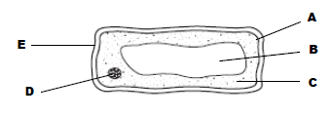

a) Name the stain that is used to show up the structures in onion cells more clearly 1

b) Label parts A to E 3

c) What is the function of part D? 1

2. Look at the drawing of a cheek cell

a) Which stain is used to show up the structures in a cheek cell more clearly? 1

b) Draw a diagram of the cell in your jotter and label parts F to H 1

3. Which three structures are found in both plant and animal cells? 2

4. The table below shows the length of five different cell types 3

|  |  |
| --- | --- |
| **Type of Cell** | **Length in micrometres (1000 micrometres = 1mm)** |
| Red blood Cell | 7 |
| Onion | 150 |
| Rhubarb | 200 |
| Cheek | 50 |
| White blood cell | 12 |

a) Draw a bar chart for the information in the table 3

b) What is the length of a rhubarb cell in millimetres? 1