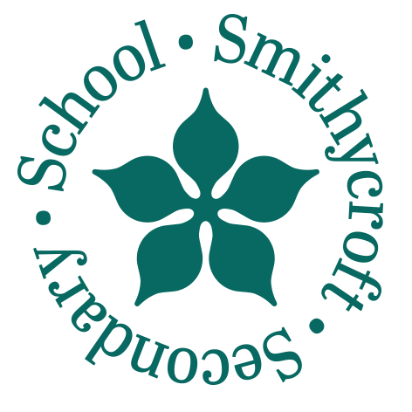

Smithycroft Secondary School
282 Smithycroft Road
Glasgow G33 2QU
Phone 0141 582 0220
Fax 0141 582 0221
Email headteacher@smithycroft-sec.glasgow.sch.uk

Head Teacher
Patrick Oberg

31st March 2026
Dear Parent/Carer,

As you will be aware, the QS (formerly SQA) examination diet is fast approaching. To help ensure that all examinations run smoothly, we have shared important information with young people in S4–S6 through dedicated assemblies this week.

We would like to highlight the key information for you below.

General Expectations
- During the study leave period, young people should only attend school when they have a scheduled exam.
- School uniform must be worn at all times when in the school building.
- Outside of exams, pupils should only attend school if they have a pre-arranged appointment with a member of staff.

Before the Exams
- All pupils should check their individual exam timetables carefully. If there are any inaccuracies, they should speak to Mrs Thompson as soon as possible.
- If your child has received an Alternative Arrangements (AA) letter, please review this carefully. If you believe any information is incorrect, contact Mrs Stobie. The letter must be signed and returned promptly to Mrs Stobie.
On the Day of the Exam
- Pupils should enter via the main entrance and register with the Teacher at the door.
- They should arrive at least 30 minutes before the exam start time.
- Pupils must know their candidate number.
- All mobile phones, smartwatches, and Meta glasses must be removed, switched off, and stored safely before entering the exam hall.

For Pupils with EAL (English as an Additional Language)
- Bilingual dictionaries should be collected from the Languages department before the exam and returned after each exam.
Key Dates
- Study Leave Begins: Wednesday 22nd April
(Please note: National 5 and Higher Spanish candidates begin study leave on Tuesday 21st April.)
- New S5 Induction Day: Monday 1st June
- New S6 Induction Day: Tuesday 2nd June
- New S5/6 Timetable Begins: Wednesday 3rd June

Yours faithfully,
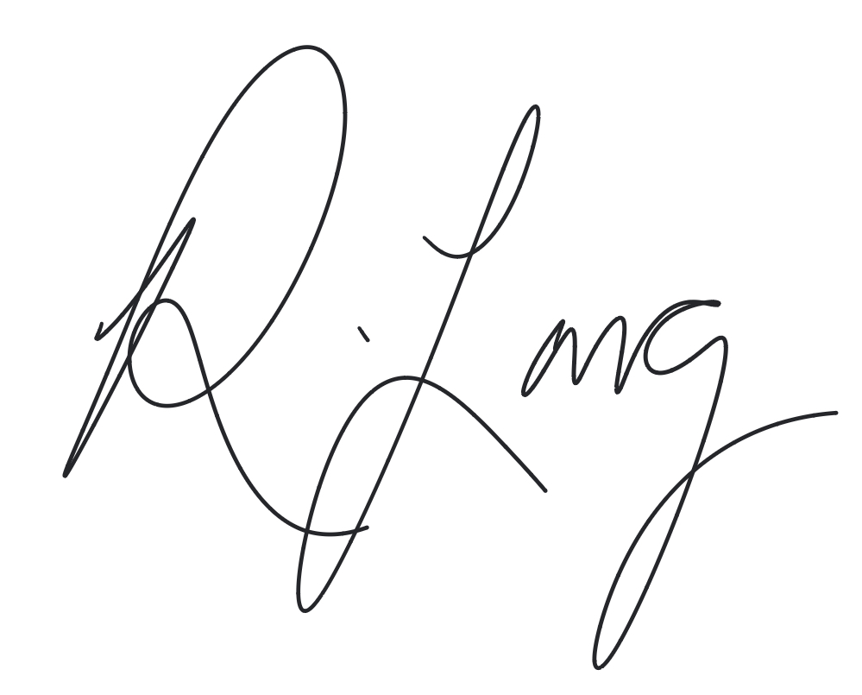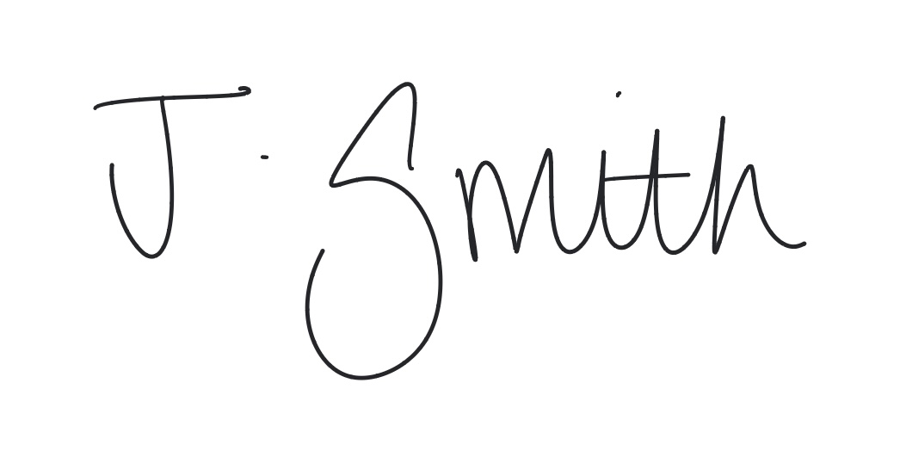

Ms Rebeca Long
Acting Depute Head Teacher (S4 and 5)
Smithycroft Secondary School

Miss Janice Smith
Acting Depute Head Teacher (S6)
Smithycroft Secondary School

Glasgow—UK Council of the Year 2015
Glasgow—Supporting the Gaelic language Glaschu — a’ toirt tai do’n Ghàidhlig
Glasgow—UNESCO City of Music
Glasgow City Council is an equal opportunities employer

