**Smithycroft Secondary School**

**BGE – S1-3**

***English Information Pack***

|  |
| --- |
| Please find some important information regarding the BGE (S1-3) English Curriculum.  Relevant points include:   1. *Brief explanation of how LEVELS and PROGRESS are tracked/assessed/recorded;* 2. *Examples of the types of activity S1-3 pupils complete;* 3. *Suggested strategies to improve English and Literacy at home.* |

1. **LEVELS**

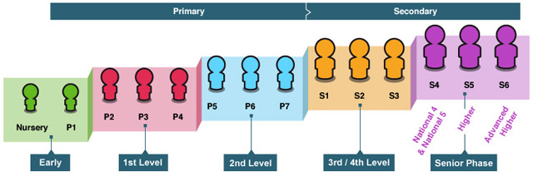

|  |  |
| --- | --- |
| **CfE Level** | **Stage** |
| **Early** | *The final two years of early learning and childcare before a child goes to school and P1, or later for some.* |
| **First** | *To the end of P4, but earlier or later for some.* |
| **Second** | *To the end of P7, but earlier or later for some.* |
| **Third and Fourth** | *S1 to S3, but earlier or later for some.* |
| **Senior Phase** | *S4 to S6, and college or other means of study.* |

1. **TYPES OF TASK**

|  |  |
| --- | --- |
| **READING** | Studying a wide variety of texts from different genres, such as:   * Prose (Novels / short stories) * Drama * Poetry * Film & TV * Non-fiction   Producing Critical Essays and completing Textual Analysis. |
| **WRITING** | **Broadly Creative**  *Personal/Reflective, Imaginative (e.g. Monologues, Drama Scripts, Short Stories, Chapters of novels…)*  **Broadly Discursive**  *Persuasive, Argumentative, Report* |
| **TALKING** | * Group Presentations * Group Discussions * Individual Presentations * On-going, discussion based co-operative learning. |
| **LISTENING** | * Responding to Questions * Active Listening assessments |
| **LIBRARY** | Fortnightly period to promote and develop reading skills. |
| **TECHNICAL ACCURACY** | A variety of strategies e.g. Nelson Spelling Programme including a special spelling notebook which pupils take home to practise. They are encouraged to Look/ Say/ Write/ Cover/ Check with an emphasis on saying the sounds phonetically e.g fri/end is freh/ end. |

**The English Department works closely with the Support for Learning Department to plan necessary Literacy interventions for pupils when required. This is on an ongoing basis.**



1. **STRATEGIES TO SUPPORT AT HOME**

|  |
| --- |
| **How to improve reading skills:**  It can help some pupils to read out loud. Some pupils find it useful to write down notes about what is happening in their book. Drawing pictures of what is happening can also be a great strategy to help show understanding.  Some easy ways to encourage reading are: put up the subtitles while watching TV/movies to build vocabulary; ask them to read out a recipe as you are cooking; or encourage them to find the information they need for their free time, like cinema times or bus timetables, on the internet. Aim to support reading as a part of life and not as a separate, homework activity.  As your child progresses through Secondary school they should also read non-fiction and journalism. You can find examples for free in any library or on the following websites:  www.telegraph.co.uk www.heraldscotland.com www.theguardian.com www.independent.co.uk    **How to improve spelling skills:**  Try splitting the word up into its separate sounds. ‘completely’ = ‘com-ple-te-ly’. ‘disorganise’ = ‘dis-or-ga-ni-se’.  Try looking for words you already know within the word. For example: - ‘young’ contains the word ‘you’.  ‘You are so young’ is a good phrase to help remember the ‘ou’ spelling pattern. - ‘believe’ contains the word ‘lie’.  ‘Never believe a lie’ is a good phrase to help remember the ‘ie’ spelling pattern.  **‘Word Talk’ i**s a free resource that will read aloud any Microsoft Word document. It’s a great checking tool for missing full stops or incomplete sentences. It would also read aloud a story or article if you copied it into a Word document, which is useful for reluctant readers but keen listeners. You can get it free here: <http://www.wordtalk.org.uk/home/>.  The same type of programme can also be found using GLOW –Immersive Reader to their GLOW account (which all pupils can access). |

**“Today a reader, tomorrow a leader.”**

**– Margaret Fuller**