The Treaty of Union

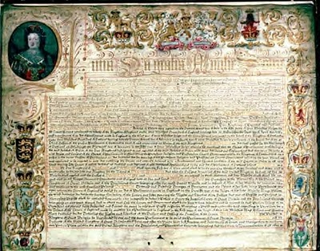
The Act of Union 1707

Revision Notes

Background

- In 1603 the Union of the Scottish and English Crowns took place.
- The first King of both England and Scotland was James VI of Scotland and I of England. He was the son of Mary, Queen of Scots.
- He inherited the crown of England after Elizabeth I remained unmarried and without heir.

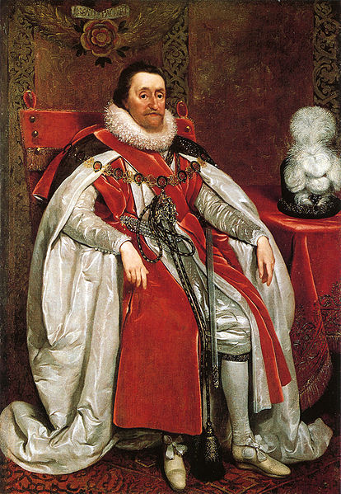
James VI and I

- In 1707 Scotland and England became one country when their parliaments were incorporated together by the Act of Union.

ISSUE 1 - WORSENING RELATIONS BETWEEN SCOTLAND AND ENGLAND

The areas that could be examined in this Issue are:
- the Glorious Revolution of 1688-89
- the role of King William
- the Darien Scheme
- English legislation
- Scottish legislation
- Issues of contention between Scotland and England.

Background - Scotland in the 1690s

- Was poor and had a very small population (1 million).
- The biggest town was Edinburgh with a population of 30,000. That’s smaller than Inverness today!
- Glasgow was still a small town on the River Clyde.

Travelling in Scotland
- It was very difficult and dangerous to travel in Scotland.
- The easiest way to travel was by sea because the road network was so limited.
- As a result, most of Scotland’s trade was with Northern Europe. This meant that the richest towns in Scotland were the trading towns on the east coast.
- England was very difficult to get to because there was only one road along the east coast that linked the two countries.

Geographical Divisions
- Scotland was divided into two different areas – the Highlands and the Lowlands.
- About half of the Scottish population lived north of Perth. This is very different from today! Much of Highland society was divided into clans.
- In the Lowlands, local power was in the hands of landlords known as lairds.
- Highland society was very different from lowland society with language and religion being two main areas of difference. Gaelic was the language and Episcopalians and Catholics were much more common here.
- All of these different religions didn’t get on and this caused further divisions.

Religious Divisions
- Scotland was a Protestant country.
- Although England was also a Protestant country, Church organisation differed greatly between England and Scotland. For example, in England the king could choose the bishops who ran the Church of England.
- In Scotland Presbyterians were against the use of bishops. They believed that each local congregation could choose its own ministers and that these ministers would manage their churches through local committees called Presbyteries. Presbyterians did not want any interference from the king.
- During the reign of Charles II (1660-1685) bishops had been reintroduced to the Scottish church. Charles also said that he was head of the church and demanded that everyone swear an oath to accept this. This was the 1681 Test Act and went against Protestant beliefs.
- When James VII and II was king, he allowed Catholics and Protestants to be tolerated in Scotland. This was opposed by extreme Presbyterians who became known as Covenanters (this was a name taken from the National Covenant signed by dissenting Presbyterians during Charles’ reign).
- Under both Charles II and James VII moderate and radical Presbyterians were persecuted. This time was known as “the Killing Time”. Many of these Presbyterians were imprisoned on Bass Rock in the Firth of Forth and were subject to extremely harsh treatment.
- Extreme Presbyterians were also capable of violence, e.g. the stabbing of the Archbishop of St. Andrews.

The Scottish Parliament
- Political power was in the hands of the king and his Commissioners (modern day MSPs).
- There were three “Estates” in the Scottish Parliament – the clergy, the nobility and the merchants or burgesses.

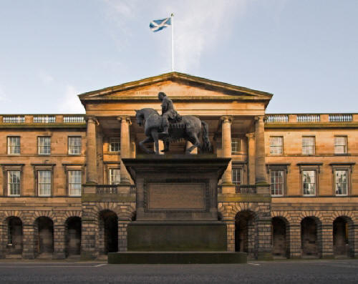
Old Scottish Parliament Building

How Much Power did the Scottish Parliament Have?
- Not much! (The Abolition of the Lords of the Articles changed this a little as it gave Parliament more power to discuss issues without them being introduced by the king or queen.)
- It could not pass laws.
- It could not even discuss and debate new laws proposed by the king.
- Ordinary people could not elect the Commissioners.
- What parliament did do, however, was raise money to pay for wars.
- The Commissioners knew that their future success depended on not offending the king.

The Glorious Revolution 1688-1689

- In 1688 James VII of Scotland and II of England was “deposed”. He fled to France when his army refused to carry out his orders.
- Parliament had been worried about James reducing their power and also about the fact that he was Catholic. Many Catholics had been appointed to key positions in the government while James was king which was seen as an abuse of power. The birth of James’ son meant that it was even more likely that there would be another Catholic king after him.
- So Parliament moved to replace him with his Protestant daughter Mary and her husband William of Orange.
- This would ensure a Protestant succession. Consequently, some Protestants named this the “Glorious Revolution”.

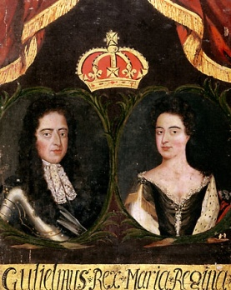
William of Orange and Mary

The English Bill of Rights 1689
- This stated that James had in fact abdicated.
- This was a document drawn up by the English Parliament for Mary and William to sign.
- It set out the division of power between the English parliament and the crown.
- As well as laying down exactly what the king could and could not do, the bill laid down an order of succession so that the Catholic side of the Stuart family should never rule again.
- Some politicians in both England and Scotland proposed a union between the two countries at this point. There had been a common hostility felt towards James by Scottish Commissioners in the Scottish Parliament and MPs in the English Parliament. His removal could therefore have facilitated a union. However, there were disagreements between the parliaments about their respective relationships with the crown.

Was James still King of Scotland?
- James had been deposed/abdicated in England.
- It was an open question as to whether or not he was still king of Scotland.
- Acting independently of James, members of the Scottish Parliament called a Convention of Estates in Edinburgh. (It was not called a meeting of Parliament because only the king could call this.)
- This Convention was to decide whether to follow England in accepting Mary and William of Orange as monarchs.

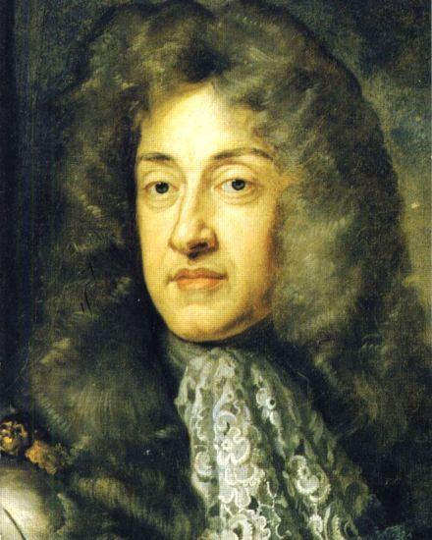
James II and VII

The Scottish Claim of Rights 1689
- This was the eventual Scottish response to whether or not James was still King of Scotland.
- It stated that James VII and II had forfeited the throne through his own actions (i.e. leaving for France).
- In April 1689 a Scottish Convention agreed to accept William and Mary as rulers of Scotland.
- William had made it easier for the Scottish Parliament to accept him as he had promised to defend Protestantism whereas James had written a threatening letter to the Scottish Parliament.

The Articles of Grievance and the Abolition of the Lords of the Articles 1690
- These were also issued by the Convention in Edinburgh.
- These set out their concerns over the conduct of James II and VII. They focused on his abuse of power and also the persecution of some Protestants during his reign.
- They also demanded that the committees which kings had traditionally used to govern Scotland called the Lord of the Articles be abolished. This happened in 1690. This freed the Scottish Parliament from control by the king and meant that the Parliament could now discuss anything it wished.

The (Protestant) Act of Settlement 1690
- With new Protestant rulers on the throne, the Scottish parliament passed an act that formally adopted Presbyterianism as the system of government of the church.
- This meant that any ruling monarch no longer had control over the Church.

King William and Scotland

- Most lowland Protestant Scots were happy with William of Orange as king.
- They were happy to accept Mary as Queen as she was the daughter of King James and Protestant.
- However, there were large groups in Scotland who were not happy with William was king.

The Jacobite Rebellion of 1689

Who were the Jacobites?
- They were the “followers of James”.
- They were people who wanted to put James VII and II back on the British throne.
- The Latin word for James is Jacobus and so the supporters of James were called Jacobites.
- As soon as the Scottish Parliament chose William and Mary, the Jacobites started to gather their forces.
- In 1689 the first Jacobite rebellion against the British Crown took place.

Why did some People Support the Jacobite Cause?
- Many of the Jacobite supporters came from the Highlands where many clans were Episcopalian or Roman Catholic. They had no love for the Presbyterianism William had promised to protect.
- Historians have argued over the claim that some clans supported the Jacobites simply because rival clans did not and it gave them a convenient excuse to fight one another.
- One thing was clear to many however – James was a Stuart and that family had been kings and queens of Scotland for hundreds of years!

The Battle of Killiecrankie – 27th July 1689
- The Jacobites had approximately 2000-2500 men, whereas the government army had about 4000 men.
- The Jacobites used their Highland Charge effectively against the government forces who fled in fear. The battle only lasted a few minutes.
- Unfortunately, the Jacobite leader, Viscount Claverhouse, was killed during the battle by a musket ball.

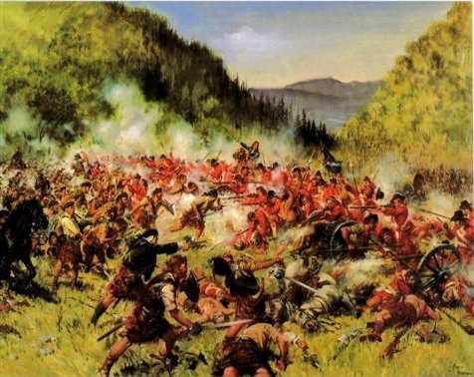
Battle of Killiecrankie

Defeat at the Haughs of Cromdale – 1st May 1690
- The Jacobite army was defeated on 1st May 1690.
- This was the end of the first Jacobite rebellion.

The Battle of the Boyne – 12th July 1690
- Jacobite forces in Ireland were defeated at the Battle of the Boyne on 12th July 1690.
- The Treaty of Limerick formalised the English conquest of Ireland.

The Massacre of Glencoe

- The events in Glencoe in February 1692 worsened relations between Scotland and England.
- 38 MacDonalds who lived in Glencoe were murdered and the rest of the clan was scattered in a blizzard.

William of Orange and the Highlands of Scotland
- William feared the Highlanders and their allegiance to the Jacobite cause.
- They were a very real threat to his position as king.
- England was also at war with France, and William knew that the French might look to cause trouble in Britain by supporting the Jacobite cause in Scotland. The French might even unite with the Scots and invade England from the north!
- In 1691 all Highland clans were told they must swear an oath of loyalty to King William by the end of the year.
- James VII released them from their still standing oaths to him. He realised the difficult position the Highlanders were in.
- The clan chief of the MacDonalds was late in making his oath due to circumstances beyond his control, but was assured his oath had been accepted.

So why did the Massacre take place?
- Possibly because of Sir John Dalrymple, the Earl of Stair.
- He was looking for a way to increase his own power in Scotland. William was very much an absentee king and Dalrymple thought he would be given gratitude, titles and promotions if he showed how loyal he was to the crown by destroying a rebellious clan.
- The MacDonalds were the perfect choice because they were Catholic, Jacobite supporters and had been late in swearing their oath.

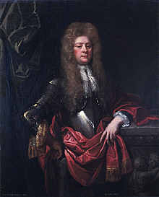

John Dalrymple

13th February 1692 – the Massacre
- A company of government soldiers had stayed with the MacDonalds as guests. The MacDonalds believed the soldiers had come to collect taxes.
- Highland hospitality meant that any group of people travelling, especially in winter, would be offered food and shelter.
- The soldiers stayed with the MacDonalds for 12 days.
- Then, on the 13th February 1692, the soldiers attacked the clansmen in their beds.
- Men, women and children were slaughtered or left to run into the mountains and die in the snow. Many did survive, but 38 died.

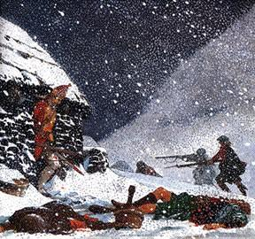
Massacre of Glencoe

The Reaction
- The story became national and international news.
- The Jacobites got hold of a copy of the orders that were seemingly sent by William and used this to discredit him and his government in Scotland. Violence and murder were nothing new in the Highlands and clans had been fighting clans for years. However, most of Scotland was outraged.
- William and his government were also condemned for betraying the trust of hosts who had offered hospitality. In Scot’s Law it was a criminal offence called “Slaughter under Trust”.
- William claimed that the Earl of Stair and various military officers were responsible for the massacre. There was no firm evidence that the king had been involved (despite another order that referred to a “sect of thieves” having the king’s signature on it twice – many claimed the “thieves” were the MacDonald clan).
- The events that supposedly took place were developed and exaggerated with stories circulating of children being stabbed as they begged for mercy and of rings being bitten off women's’ fingers.
- John Dalrymple was punished with a temporary suspension from his duties. This was not a harsh punishment at all!

The Darien Scheme

Scotland’s Colonial History
- In 1632 Scotland lost her only colony – Nova Scotia in Canada – as a result of an English War with France that Scotland had been dragged into because of the Union of the Crowns.
- Later England’s Dutch wars compromised valuable trading privileges that Scottish merchants had previously enjoyed.
- Scottish overseas trading activity was further frustrated by the Navigation Acts which forbade goods to be imported into England or its colonies unless carried in English ships. This meant that Scotland could not trade with these colonies.
- To make matters worse two powerful English trading companies, the East India Company and Royal Africa Company, claimed a monopoly of the rich trade with the East Indies and Africa.

Scotland and Darien
- In the 17th Century a few Scots came to hear of a place called Darien.
- A man called William Paterson decided that Scotland’s Parliament should grant a monopoly of trade with Africa and the Indies to a Scottish trading company.
- A key part of this plan was the establishment of a Scottish colony in Central America at a place called Darien (now part of Panama).
- There were some Scots who hoped to profit from using the colony to control all trade with the Americas and from the fact that it would short cut the long and dangerous sea routes to the East around Cape Horn or the Cape of Good Hope.

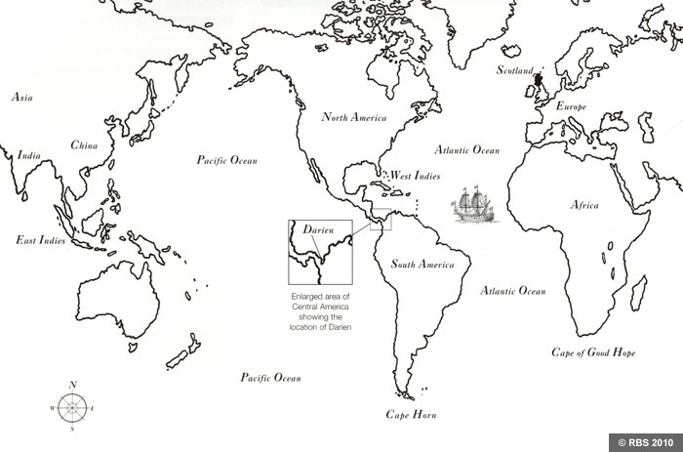
Map Showing Darien and the locations of Cape Horn and the Cape of Good Hope

How the Colony Would Work
- Goods would be transported to the colony on the eastern site of Darien and carried across the narrow isthmus (narrow strip of land with water on both sides) to a port on the western seaboard.

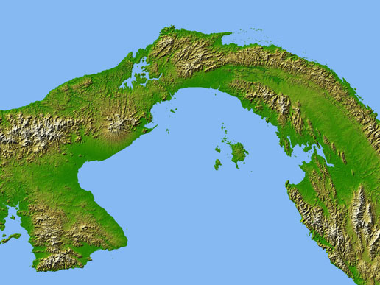
Isthmus of Darien

Paying for Darien
- The Scots decided to set up a company called the Scottish Trading Company to organise the colonising of Darien. It was set up in 1695.
- To do this, they needed subscribers to contribute to the costs involved, e.g. Raw materials, ships, staff etc.
- They needed £600,000 – half subscribed in Scotland and half in London.
- In 1695 a subscription book was opened and wealthy people from both Scotland and England were invited to put some of their money forward to help fund the exciting new venture. They could expect to share in the profits in return.
- However, the powerful directors of England’s East India Company were not happy. They thought their trading monopoly and business would be ruined by the Scottish Trading Company.
- They appealed to King William and the English Parliament. Incidentally, King William was trying to stay on the Spanish King’s good side at this point in history. The opposition of the East India Company combined with his need to not upset the Spanish by allowing the Scots to set up a colony in what was already Spanish claimed territory.
- King William threatened the directors of the Scottish Trading Company with Impeachment which resulted in English investors removing their money.

Scottish Reaction
- Scotland was furious!
- They decided that they would still raise the necessary money but without the help of England.
- By August of 1696 they had raised the necessary money. (Revised to £400,000). This was about half of Scotland’s total capital. Much of this money was embezzled and never recovered.
The First Journey
- Ships and provisions were bought mainly from Holland and Germany. There were a total of 5 ships with their own crews.
- Their names were Caledonia, St.Andrew, Unicorn, Endeavour and Dolphin.
- The first expedition left the Port of Leith on the 18th July 1698 with around 1,200 people including William Paterson himself. Given that Scotland’s population was only about a million, this was a huge amount of people.

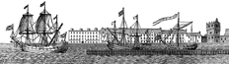
- The colonists reached Darien in November of 1698.
- They called it New Caledonia.
- However, things soon went wrong – agriculture proved difficult, local Indians proved unwilling to trade, no merchant ships appeared to make use of the Isthmus, the English colonies in North America had been instructed by King William not to supply the Scots at Darien, and the hot and humid climate did not agree with the Scots, many of whom died of fever.
- In July 1699 the colony was abandoned.

A Second Expedition
- People back in Scotland had no idea the colony was abandoned and a second expedition of 1,300 people set sail on The Rising Sun in August 1699.
- They were shocked when they arrived at the deserted colony, but decided to rebuild it.
- They also won a pre-emptive fight with the angry Spanish. It was feared that the Spanish would attack the Scots in an attempt to reclaim their territory. Therefore, the Scots felt it best to attack first.
- However, in April 1700 the Scots finally gave up due largely to the diseases and illnesses that were ravaging the colonists.

The Legacy of Darien
- Around one quarter of Scotland’s assets were lost in the venture.
- Two thousand people died.
- Blame was directed at England firstly for withdrawing its financial support in the subscription stage.
- They also blamed England for not allowing their colonies to help the struggling Darien colony.
- In 1704 an English merchant ship, Worcester, was driven into the Firth of Forth by bad weather. The ship was seized and its captain and two other men were executed. The Scottish claimed this was because that ship had sunk one of the Company of Scotland’s ships. This claim was unfounded. However, it did emphasise the bitterness felt towards England by many Scottish people.
- The Darien disaster, together with a series of bad harvests, had caused enormous suffering and distress in Scotland. The Treaty of Union provided for free trade and navigation. There was also a payment of £398,000 in compensation for the Darien losses and to help Scottish industries. This was known as the “Equivalent”. The distribution of the Equivalent was eventually organised by a company that was to become known as the Royal Bank of Scotland.

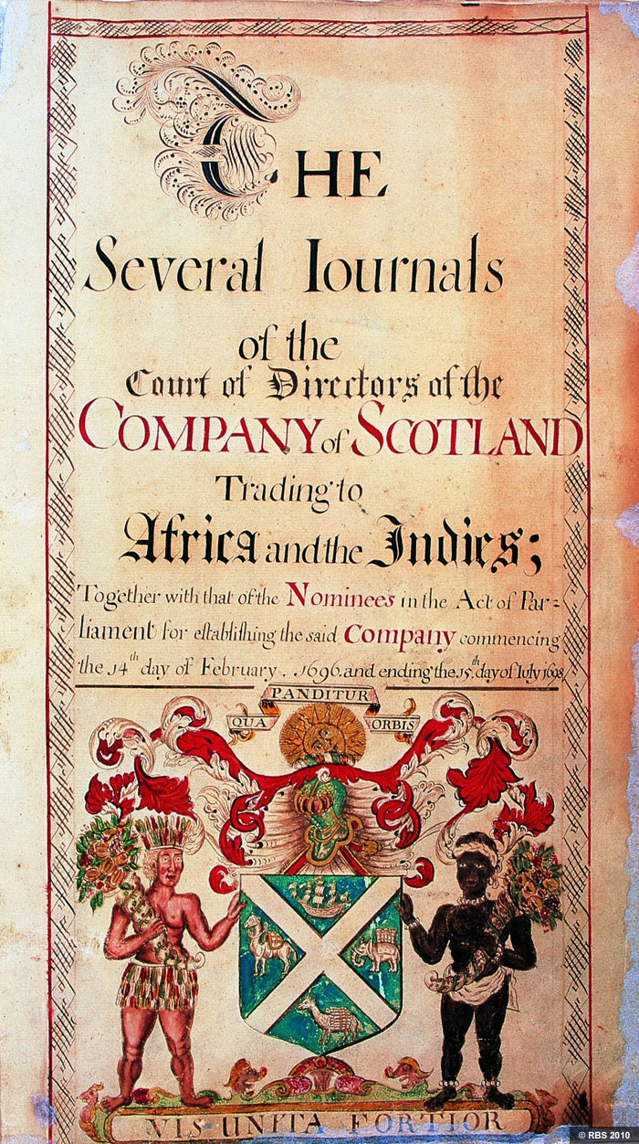
Company of Scotland Trading Journals

The Legislative Wars 1701-1705

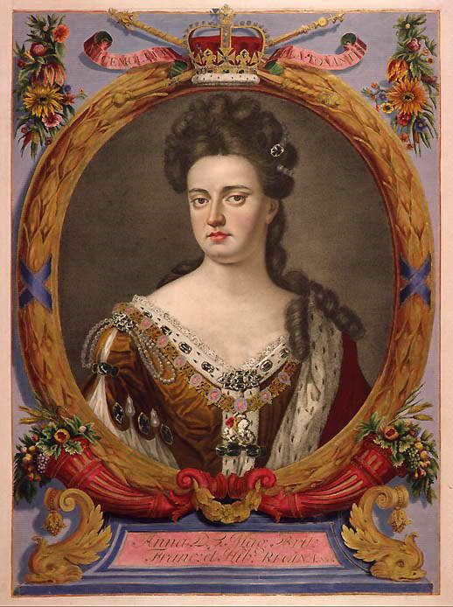
- Princess Anne was heir to the British throne after William of Orange.
- However, her children had all died before 1700 so she had no heirs.
- She succeeded William to the throne in 1702.

Legislation: the process of law making.

Queen Anne

The Act of Settlement 1701
- The English Parliament passed this act in 1701.
- It stated that the throne of England would pass to Sophia of Hanover (Protestant grand-daughter of James I and VI) following Anne’s death.
- This was known as the Hanoverian succession.
- The English Parliament had assumed that Scotland would accept the Act of Settlement and hadn’t actually asked them if this was okay.
- The Scots saw this as typical English arrogance.
- Since the Abolition of the Lords of the Articles (1690), the Scottish Parliament now had more power than previously and was keen to demonstrate this to the English Parliament.

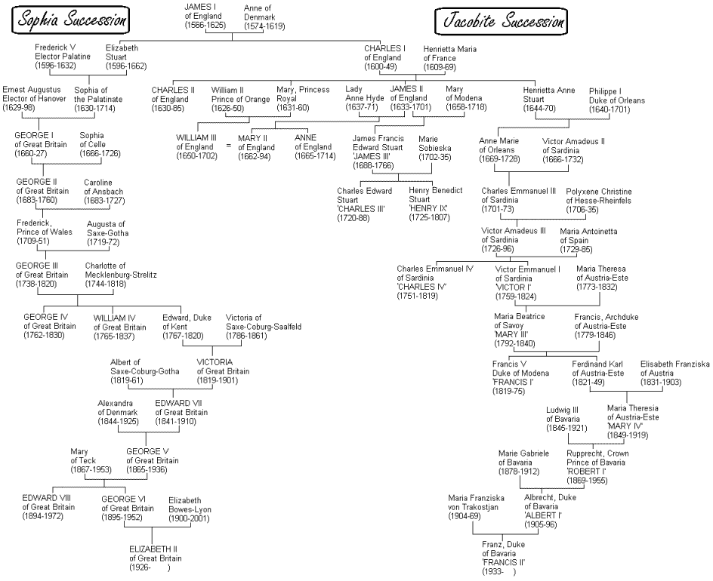
Family Tree showing the Hanoverian succession and the Jacobite line

The War of Spanish Succession
- King Carlos II of Spain died in 1700 without heir. This was the result of inbreeding.
- Carlos left the Spanish throne to Philip of Anjou, the grandson of Louis XIV of France.
- England saw this as a threat. The thrones of Spain and France could be united on the death of Louis XIV. Also in 1701, Louis XIV had recognised James II and VII’s son James III and VIII as the rightful king of Britain and not Queen Anne.
- This led to the War of the Spanish Succession to try to prevent French domination of Europe.

The War of Spanish Succession and Scotland
- The Scots were ignored over whether or not they wanted to fight in the Spanish War of Succession.
- The Scottish Parliament should have been summoned within 20 days of William of Orange’s death by Anne, but did not meet until 90 days after his death.
- By that time, the English Parliament had already entered the War of Spanish Succession.
- The Scottish right to make independent decisions had been ignored.
- As a result, there was a war of legislation between Scotland and England.

Scotland’s Legislation against England during this period
- The Act anent (about) Peace and War – Scottish Parliament’s permission was needed before any king or queen could make war, make a peace treaty or form alliances with other countries. This in effect meant that Scotland might not help in England’s wars.
- The Wool Act – banned any wool imports from England to protect Scottish industries. This was viewed as openly aggressive to English trade.
- The Wine Act – allowed foreign wines, including French ones, to be imported into Scotland.

The English Reaction to Scotland’s Legislation
- People in England began to worry that there may be a war with Scotland too.
- Lord Godolphin, Queen Anne’s chief minister, needed Scotland to calm down so he allowed Scotland to pass the Wine Act. To continue funding wars, England needed Scottish taxation.

The Scottish Act of Security 1704
- This was another piece of legislation passed by Scotland and it stated that Scotland might not accept the same succession as England.
- The Scots wanted guarantees of Scottish independence from English interference. They also wanted trading access with all of England’s colonies.

The English Reaction to the Scottish Act of Security 1704
- If the Act of Security was allowed to go ahead, Scotland would be able to decide on their own foreign policy at a time when England was involved in the Spanish War of Succession.
- The Scots might also decide to appoint their own king, who could potentially favour an alliance with France.
- Luckily for England, the war in Europe turned in England’s favour with the Duke of Marlborough’s victory at Blenheim. They could now take a stronger stance on Scotland.

The English Aliens’ Act 1705
- In 1705 the English passed the Aliens’ Act. This act was to come into effect by the end of the year if the Scottish had still not accepted the Hanoverian succession or entered into negotiations for a union.
- It threatened Scottish estates in England as well as banning trade in three key areas – cattle, coal and linen.
ISSUE 2 - ARGUMENTS FOR AND AGAINST A UNION

The areas that could be examined in this Issue are:
- Arguments for union with England
- Arguments against union with England

Federal versus Full Incorporating Union

- A federal union would have allowed Scotland to keep its own Parliament, laws and church. There would be cooperation with England on trade and other issues.
- A full incorporating union meant the union of the Scottish and English Parliaments into one single parliament based in Westminster. This parliament would control both countries.
- Many in Scotland were in favour of a federal union for the following reasons:
  - closer links in trade
  - retention of separate identity
  - Scotland would keep its own parliament
  - Scottish Presbyterianism would definitely survive Anglicanism
  - Scottish rights, laws and customs would remain
  - Scottish manufacturing would be protected from English competition.
- However, England was only willing to consider a full incorporating union.

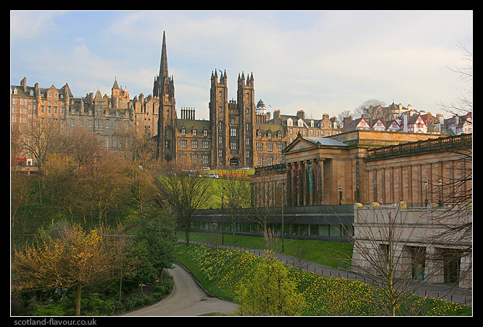
Old Scottish Parliament Building

England’s Thoughts on a Union with Scotland

Arguments for a Union | Arguments against a Union
- England feared Scottish invasion while they were engaged in a war with France. Union would mean this would no longer be an issue.  - Scotland had raised the possibility of appointing their own monarch. This was a threat to England.  - Scotland threatened England’s international trade with their ability to get around the Navigation Act. (Union would also mean that England would be able to learn how to do this in relation to other countries.)  - Union would make Scottish manpower available for a number of purposes.  - Scottish soldiers were highly skilled and would be a valuable asset to England. | - Scotland was the “poor neighbour”. There was no advantage to Union for England.  - Scotland would access England’s wealth which might weaken the country.  - Queen Anne was decidedly uninterested in Scotland.  - They would have to allow Scotland to have access to their colonies for trading.

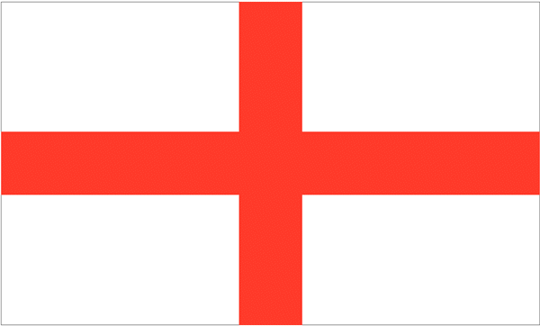

Scotland’s Arguments Against a Union

Economic Arguments Against a Union
- Many people in Scotland believed a union would bring about higher taxation as English taxes were set at a higher rate than Scottish ones.
- They also worried that the English / British Parliament based in London would favour English trade over Scottish trade. They held up the Darien Scheme as an example.
- There were fears for the Scottish manufacturing industries as English goods would be available at a lower cost and in some cases better quality.
- A union would also mean having to adopt the English currency, weights and measures.
- Scotland would also lose some of its European trade as English concerns would outweigh Scotland’s. For example, England would hardly allow Scotland to continue trading with France.

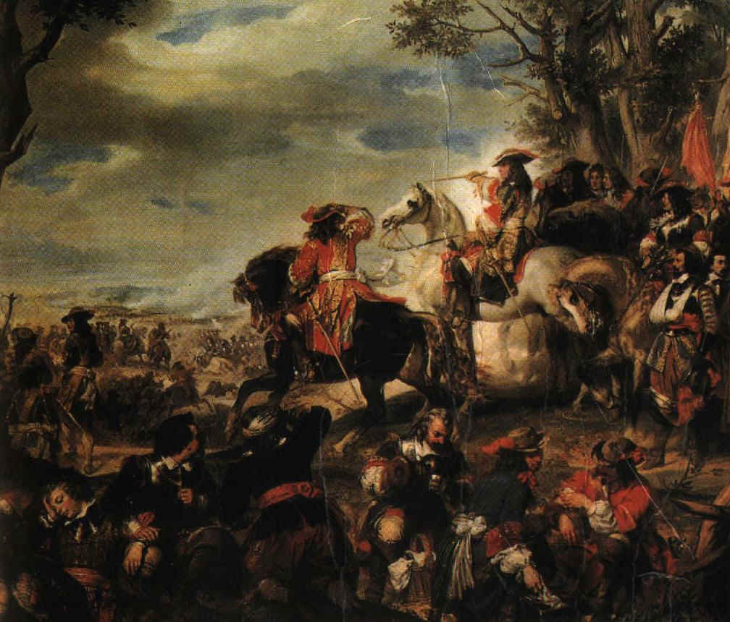
War of the Spanish Succession

Political Arguments Against a Union
- Many felt that Scotland’s independent sovereignty was being lost.
- Scottish Landowners thought their status would be reduced in the new British parliament.
- The Scottish Claim of Right accepting William of Orange as monarch and asserting the reduced relationship in Scotland between the crown and parliament would no longer stand.
- Many did not like the end of Scottish independence. They believed Scotland would become “Scotlandshire”.

Succession Issues used as Arguments Against a Union
- If they accepted Union, Scotland would also have to accept the Hanoverian succession.
- This would mean the end of the Stuart line in Scotland.
- Some felt that this threatened Scottish identity.

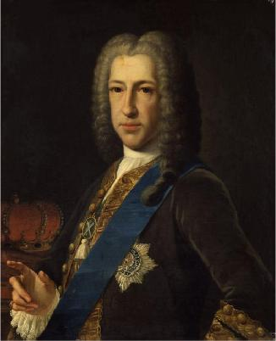
James Stuart, the Pretender to the Throne

Religious Arguments Against a Union
- Presbyterians were worried that a Union might mean Scotland having to adopt the Anglican church complete with bishops.
- The English parliament had many Episcopalian members and bishops held seats in the House of Lords.
- Interestingly, some Scottish Episcopalians (north east and Highland clans) opposed Union despite the high ranking English Episcopalians because they believed only the restoration of the Stuart line would restore episcopacy to the Scottish church. Union ended the Stuart dynasty.

Social Arguments Against a Union
- There were lots of people in Scotland who opposed the Union. Indeed, general public opinion in Scotland opposed the union.
- There were also fears that the Scottish legal system would disappear.

Self-Interest Arguments Against a Union
- The 2nd Lord Belhaven opposed union because he did not want his life to have to change.
- The Duke of Hamilton also opposed union when it suited his own financial and property interests.

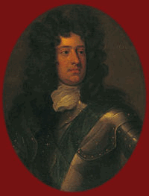
James Hamilton, 4th Duke of Hamilton

Why did Scottish Opposition Fail?
- The different groups opposed to union were not strongly united. The Jacobites and Covenanters in the south-west of Scotland had planned a rising against union in December 1706 but called it off because of disagreements.
- The Duke of Hamilton was not a strong leader of the opposition – he was prone to mind-changing!
- Popular opposition to the union was largely ignored.

Scotland’s Arguments for a Union

Economic Arguments For a Union
- The Scottish economy was in a very poor state in the early 18th Century.
- Union with England would mean that Scotland could access England’s colonies. This had been prevented since the Navigation Acts of the 1660s.
- Access to England’s colonies would allow Scotland to compete on equal terms with other European countries.
- This would increase prosperity in Scotland.

Political Arguments For a Union
- As part of a united Britain, some argued Scotland would be less likely to face threats from other countries.
- Some thought that Scotland and England had a long standing common interest which had been brought closer together by the union of the crowns. Union of the parliaments was a natural progression from this.
- The monarch had a long standing role in appointing Scottish politicians anyway.

Succession Arguments For a Union
- A Union would secure the Hanoverian Protestant succession and therefore protect Scottish Presbyterians.
- There would be no question of the throne returning to the Stuart line.

Civil War Fears and Military Fears about England
- England’s military power was much increased due to their ongoing involvement in European wars. The Duke of Marlborough had also just won impressive victories over the French.
- Ireland had also been conquered by the English and had lost their colonial trade with America as a result. Scotland did not want to end up like Ireland.
- John Clerk of Penicuik also feared that not accepting a union would lead to civil war between England and Scotland.

Personal Interest
- George MacKenzie, the 1st Earl of Cromartie supported union because he wanted to advance his own political career.
- John Ker, the 5th Earl of Roxburghe was the leader of the Squadron Volante (see below) who eventually supported union. He was given a dukedom by Queen Anne in recognition of his supporting the Union. He was able to build himself a castle to celebrate!
- Union also guaranteed the traditional powers of the landed class.

The Benefits of Empire
- Many career opportunities were available in the empire, particularly in the army.

Religious Arguments For a Union
- The threat of “Popery” would be reduced by a Union.
- The Act of Settlement (passed in England) that secured the succession of Electress Sophia meant that no Catholic could become monarch.

Social Arguments For a Union
- A lot of people lived in terrible conditions in Scotland. People saw Union as a way of improving things.
- Levels of poverty were extremely high and Scotland lagged behind the rest of Europe economically.
- Farmers often went bankrupt and many felt that Union would provide a more stable economic background for them.

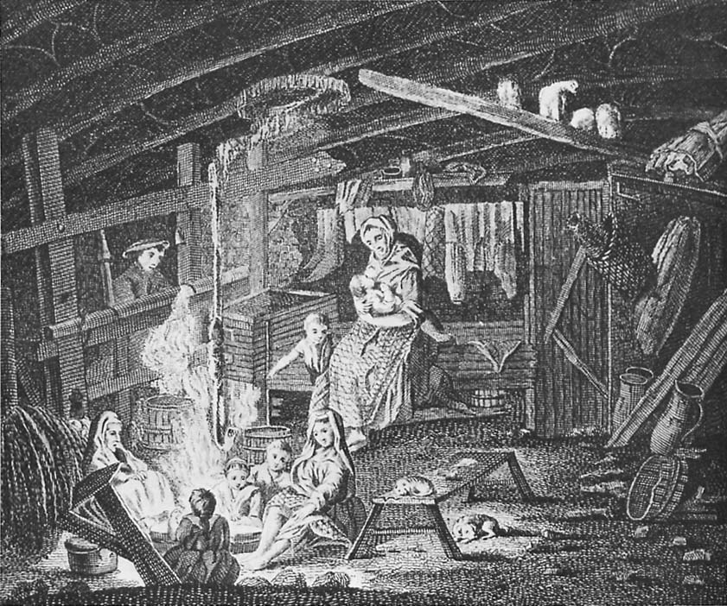
Typical living conditions for many people in 18th Century Scotland

ISSUE 3 – THE PASSING OF THE TREATY OF UNION

The areas that could be examined in this Issue are:
- The position of England on union
- Arguments for federal union (see Issue 2 Section)
- Arguments for incorporating union
- Treaty negotiations in London
- Positions of members of the Scottish Parliament
- Issues discussed during the debate on the treaty
- Reasons for passing the Act of Union.

The Debate on the Act of Union

Background
- In September of 1705, the Duke of Hamilton advised Queen Anne to move ahead with negotiations for a union between Scotland and England.
- As Anne got to appoint the Scottish commissioners, she chose the ones most likely to support union.
- The Duke of Hamilton was the leader of the opposition to the union. Why he made this strange move has been the subject of much historical debate.
- Negotiations for the union began on the 16th April 1706 in London.
- The English commissars proposed a full incorporating union.
- The Scottish commissars proposed a federal union. This meant that nothing much would change, but that Scotland would accept the Hanoverian succession. However, the English were prepared to accept nothing less that a full incorporating union. Consequently, the Scottish commissars agreed to negotiate this believing that they could get a good deal for Scotland.

England’s Initial Offers
- Assurances for Scottish peers that they would retain their tradition landed rights and privileges.
- Assistance for the Scottish economy in relation to taxation.
- A sum of money called the Equivalent to match the losses of the Darien Scheme and to compensate the Scots for their share in the English debt that they would inherit following a union.

The Divisions in the Scottish Parliament
- The Court Party – in favour of union and traditionally supported the crown.
- The Country Party – against a union and interested in protecting the interests of Scotland over those of England.
- The Cavalier Party – against a union. However, they were Jacobites and often did not agree with the Country Party.
- The New Party – eventually supported union, but frequently changed their minds before coming to this consensus. They were nicknamed the “Squadron Volante” because they were thought to be like a flying squad constantly switching from one side to the other.

Issues Discussed
- Most of the Scottish Commissars in favour of a union wanted one which was fair and equal.
- Those in favour of a union wanted the Aliens Act to no longer exist as they feared the impact on the Scottish economy if it was enforced.
- Those against a union worried that as the Hanoverian succession had been accepted, only those Scots who had supported this would get to hold key positions in the Scottish government. This meant that England would always influence this government and policy.
- Many opponents to union said that the new British government would always favour English interests over Scottish.
- Some did not think that the losses from Darien would be completely solved by union.
- Many did not think Scotland was represented strongly enough in the British government – there would be 45 MPs in the House of Commons and 16 peers in the House of Lords. Many English counties alone were close to this representation. Cornwall had 44 MPs.

Unrest in Scotland
- There was mob violence in Edinburgh and other towns because people were opposed to union.
- Jacobites were unhappy at the thought of complete links with England and an end once and for all to the Jacobite succession.
- Covenanters were also restless because union meant that the National Covenant of 1638 (This had demanded a free Scottish Parliament and a free General Assembly with no interference from the king. This document had been signed by nobles, ministers and thousands of ordinary Scots.) would never be observed in Scotland.

Key Dates in the Debate

Date | Event
3rd October 1706 | Debate began in the Scottish Parliament.
15th October 1706 | A vote to continue with the debate took place.
15th-31st October 1706 | The 25 Articles of the Act were discussed without action being taken.
29th October 1706 | A Convention of Royal Burghs made an address to parliament favouring a federal union that would maintain independence for Scotland’s Parliament.
1st November 1706-14th January 1707 | The articles of the Act were discussed again with votes taken.
12th November 1706 | Act of Security passed to make sure the Scottish church remained Presbyterian.
14th November 1706 | The second article of the Act of Union was passed. This made trade concessions to Scotland.
28th November 1706 | English government made concessions on a tax on liquor. This encouraged many to support union.
Late November | The Duke of Hamilton, leader of the opposition to union, called off an uprising of Covenanters and Jacobites because of disagreements.
16th December 1706 | Concessions made to Scotland on wool exports. Again this encouraged many to support union.
26th December 1706 | Concessions made to Scotland on a tax on salt.
16th January 1707 | The Act of Union was passed by the Scottish Parliament.
22nd January 1707 | The debate on the Act of Union began in the English Parliament.
4th March 1707 | Act of Union passed by the English Parliament.
6th March 1707 | Act of Union approved by Queen Anne.

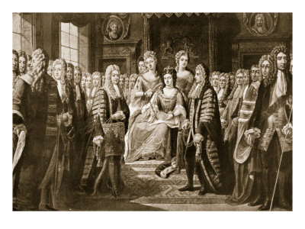
Queen Anne approving the Act of Union

The Articles of Union
(A Summary – for the full articles see the transcript of the act on pp.70-73 of your textbook)

- The New Kingdom of Great Britain began on 1st May 1707. A new flag was created out of the crosses of St. George and St. Andrew.
- The Scottish Parliament was abolished. Scots were to be represented by 45 MPs in the House of Commons and 16 Lords in the House of Lords.
- Scotland and England were joined economically. There was to be one currency and Scotland was to have access to all English ports and colonies.
- Scotland had to share England’s national debt. Scotland was paid the Equivalent to help ease their tax burden as a result of taking on this debt.
- Scotland gained tax breaks to help it adjust economically to union with England.

Why the Act of Union was Passed

Political Reasons for Passing the Act of Union
- Some groups in the Scottish Parliament believed they would have a share of the Equivalent if the Act was passed.
- The Duke of Hamilton’s change of heart divided the opposition to the union.
- There was also disagreement between other opponents of the union, such as between the Jacobites and the Covenanters.

Economic Reasons for Passing the Act of Union
- The English promise to help the Scottish economy, particularly in relation to taxation won over many people.
- There would also be increased trade because Scotland would be able to continue to trade with their traditional European partners as well as with England and England’s colonies.
- The English also made trading concessions on salt, wool and liquor.

Financial Reasons for Passing the Act of Union
- Many Scottish ministers and politicians were given payments for “services” given to the government. The English government paid out a total of £20,000. Many perceived these payments as bribery.
- The Equivalent was also paid to various important Scots to cover the future cost to Scotland of taking on English debt.
- Some nobles agreed because they feared losing their pensions if they did not.
- All Scottish peers were also guaranteed to retain their privileges which included immunity from some crimes.

Self Interest Reasons for the Passing the Act of Union
- The rights of Royal Burghs were to continue and lords would still get their inherited titles. Also, Scottish law and the Scottish court system would not be changed. This meant that many in parliament thought that union would allow their lifestyles to continue in relation to property, rights and legal privileges.
- The Act of Security passed during the debate also meant that Presbyterianism would remain as the religion of Scotland.
- There was also the threat of the Alien Act of 1705 being reintroduced.

Military Reasons for Passing the Act of Union
- Many thought Scotland would be safer after a union with England.
- There was reason to suggest that England would invade Scotland if Scotland did not agree to a union and force the treaty through. Many believed it would be better to agree to a union rather than have to accept one as the result of conquest.

Historical Reasons for Passing the Act of Union
- There had been many attempts in the past to unite the two countries.
- In 1707 however, both countries wanted and needed a union.

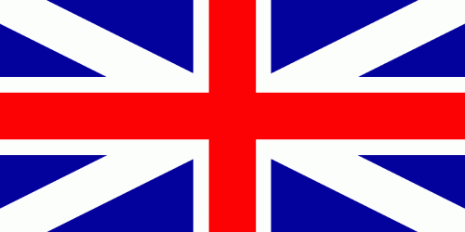
British flag in 1707

Was Scotland “Bought and Sold for English gold?”

The £20,000 in Payments
- George Lockhart of Carnworth, a Jacobite and opponent of Union claimed that the £20,000 England was paying to certain Scottish Commissars was bribery. Many people believed these claims.
- Robert Burns and Sir Walter Scott both believed the claims. Robert Burns even wrote a poem about it with the words “bought and sold for English gold” in it.
- Some modern historians also believe the claims!
- Other historians, such as Mitchison, argue the £20,000 was payment for salaries owed and not bribery at all.
- Another historian, Johnstone, points out that most of the payments went to Commissars from the Court Party. These were already in favour of Union. Only a small proportion went to the opposition parties. He argues that if the money was bribery there would have been more payments made to the opposition parties, such as the Country Party and fewer, if any, made to those in favour of union.

The Equivalent
- The Equivalent works out to approximately £56 million today.
- The stated purpose of the Equivalent was to help compensate for the Darien losses and to assist Scotland in taking on English debt.
- George Lockhart once more claimed that this was English bribery.
- Ferguson, a historian, also believes the Equivalent was a bribe. He bases this claim on his belief that the only reason the Squadron Volante eventually voted in favour of union was because they were hoping to control who got money from the total sum of the Equivalent.
- Johnstone argues against this claiming that the Squadron Volante voted in favour of union because they got the terms they wanted and that the people who voted in favour of union had not suffered losses in the Darien Scheme. Therefore, the compensation aspect did not affect them.

Pensions, promotions and job positions
- It was very clear to most politicians that if they wanted to continue to do well in their political careers they needed to vote in favour of union.
- The Duke of Queensberry, the Queen’s Commissar in Scotland, made it clear that those who did not vote for union would not receive any rewards.
- Many who supported union were rewarded with pensions, promotions and improved job positions. John Campbell the 2nd Duke of Argyll gained a military promotion and earldom for his brother for supporting union. Clerk of Penicuik became the high ranking Baron of the Scottish Court of Exchequer.
- However, 13 Court Party members voted in favour of Union but received no rewards at all.
- Daiches argues that those who were always in favour of union were rewarded as a means on political management by the English court.

Did Scotland get a Good Deal?

Professor A.I Macinnes argues that the Scottish politicians who negotiated the union were incompetent and that Scotland did not get the best deal that they could have done.

Arguments to show that Scotland did get a good deal
- Various amendments were made to the articles of the treaty based on the debate in the Scottish Parliament. This convinced many at the time that they were getting a good deal.
- Article 4. They got access to England’s colonies. England had refused this in 1702.
- Article 15. They were compensated for their losses in the Darien Scheme. Again England had refused to do this in 1702.
- Article 24. The Scottish crown jewels were allowed to stay in Scotland.
- Scotland got to remain Presbyterian.
- Scotland gained more MPs and peers than they would have got based on the wealth of their country in relation to England.

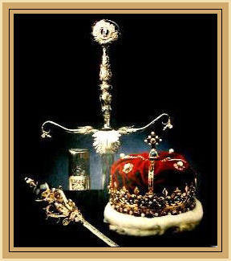
Scottish Crown Jewels

Arguments to show that Scotland did not get a good deal
- The Whig party of England expected Scotland to negotiate for better terms than those they got.
- Article 15. This was the article that settled the Equivalent. England had been considering a much larger amount of money in 1705. Also Scotland did not make sure that they would receive all of the Equivalent in one lump sum. In fact it took 20 years for the full amount to be paid.
- Article 15. This put an end to the Company of Scotland, but allowed the English East Indies Company to continue to exist. This was hardly fair.
- No money was made available to help the Scottish manufacturing industry.
- Article 5. Scotland was no longer allowed to trade separately with the Dutch. This had been very lucrative for them before the Union.
- Article 18. Scotland now had to pay the same level of taxes as England.
- Scottish MPs and Peers were hugely outnumbered by their English counterparts in the new British Parliament. There were 513 English MPs and 196 peers.
- Article 24. The English seal continued to be used to authorise documents from the new British Parliament. Surely a new seal should have been designed?
- There was room in the Articles for England to interfere in Scottish law, the Scottish Church and local government.
- The landed classes did not do as well as they had hoped because Scottish manufacturing was not assisted in the union.

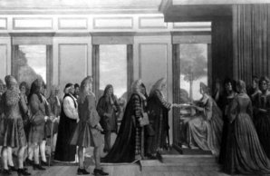
Queen Anne signing the Treaty of Union

ISSUE 4 – THE EFFECTS OF UNION

The areas that could be examined in this Issue are:
- Political effects of Union
- Economic effects of Union
- Social effects of Union
- Religious effects of Union
- Jacobite opposition

Political Effects of Union

The following is a timeline detailing the political effects of Union on Scotland (for more detail on each event see below):

Date | Event
1708 | The Scottish Privy Council is abolished.
1709 | The English Treason law is extended to Scotland.
1711 | Scottish peers prevented from gaining seats in the House of Lords.
1713 | The Earl of Findlater (Scottish) proposes a motion to the repeal the Act of Union, thereby demonstrating the extent of the discontent with the Union amongst some in Scotland.
1725 | The Scottish Office for Secretary of State is abolished and the Office of Home Secretary created.
1742 | The Scottish Office for Secretary of State is briefly re-established before being abolished once more.

The Duke of Hamilton
- The Duke of Hamilton had supported the passing of the Treaty of Union. One of his rewards for doing so was a British peerage, the Duke of Brandon.
- However, he was not granted the right to sit in the House of Lords. Therefore, his peerage was little more than a title and a disappointment to him.

The Privy Council
- The Privy Council was a body that advised the King. Amongst many other roles, its main responsibilities included administering the law, regulating trade and shipping, granting licences to travel and administering oaths of allegiance.
- The Privy Council was abolished in February 1708. Many in Scotland believed this was unfair on Scotland.

The Equivalent
- The Equivalent was a sum of money to compensate for Darien and ease Scotland’s new tax burden following Union.
- However, it took over 20 years for the Equivalent to be fully paid.

Scottish Law
- The Articles of Union had stated that Scotland could keep most of its own laws, but that these could be altered in the future by the British government.
- In 1708 the English Law of Treason was extended into Scotland after a Jacobite rebellion. Many people resented this new English law, especially the Jacobites. They believed that England was abusing the Union.

Economic Effects of Union

- The Union did not immediately bring economic prosperity to Scotland.

Smuggling
- The Union meant that customs taxes were five times higher than they had been before 1707.
- To avoid these higher customs there was a rapid growth in smuggling.
- Between 1715 and 1717 62% of all imported goods to Scotland were smuggled.

Riots
- In 1725 there were riots in Shawfield in Glasgow when attempts were made to collect a Malt Tax.
- This also caused riots in Paisley, Stirling, Dundee, Ayr and Elgin.
- The Porteous Riots in Edinburgh occurred following the execution of a smuggler. As living standards remained low in Scotland, smugglers were treated as heroes.
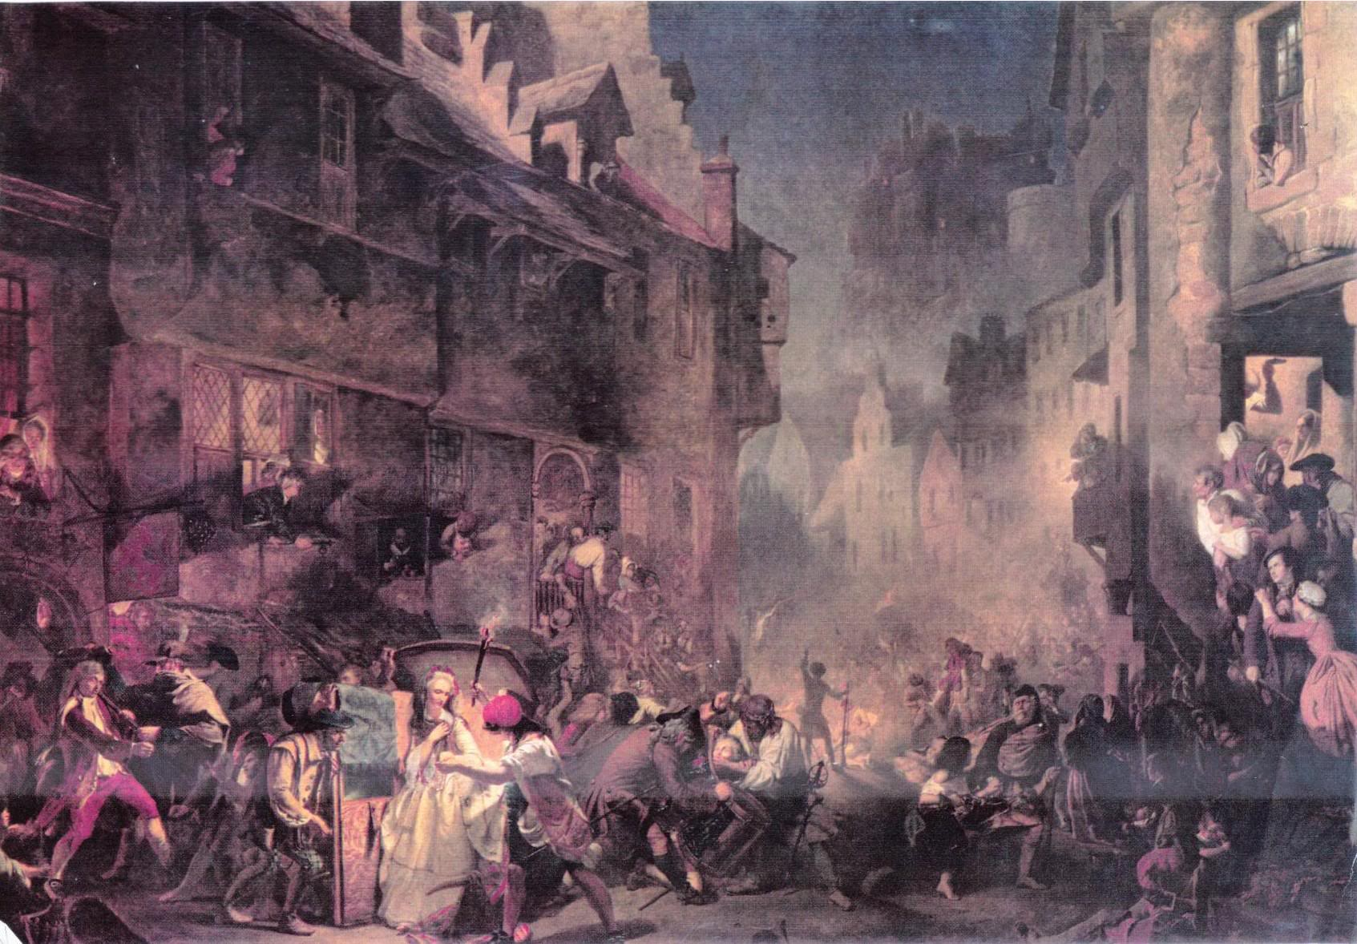
Porteous Riots

The Effect on Scottish Industries
- The wool industry was hard hit. Exports of wool were banned and the Scottish wool industry could not compete with the English which supplied cheaper and better quality wool.
- The linen industry was also badly damaged by a 1711 increase in export duties.
- A tax was out on salt exports in 1711 which caused riots.
- In May 1713 a Malt Tax was introduced. This actually broke the terms of the Treaty of Union and led to demands by some in Scotland to end the Union.
- Brewing, paper-making, east coast fishing, shoe making and candle making were someof the other industries badly affected.

The Scottish Court of Exchequer
- This was the body responsible for customs and excise in Scotland, but it followed an English model and had an English judge in charge.
- However, on a positive note it did give the Scots experience of laws relating to trade and business.

Social Effects of the Union

An Unpopular Union?
- Many opponents of Union continued to state that most people in Scotland were against the Union after 1707.
- The people of the Highlands were very unhappy after 1715 about confiscated Jacobite lands and the Disarming Act.
- A new Scottish newspaper was (re)formed called the “Caledonian Mercury”. It was seen as a way of having something that was just Scottish.

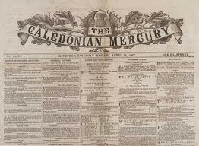

- In the 1720s there was an outbreak of fence smashing! This was in response to the replacement of the Runrig farming system with Enclosures. Whilst this did improve efficiency, it also led to job losses and poverty amongst those who could not afford the bigger farms.
- The London government built many forts in the Highlands to establish their control of these areas. They also formed Highland sections of the British army, such as the Black Watch.
- Highland tenants found that their landlords were now more focused on England and would often be exploited for their landlords financial gain.
- In 1739 Scotland published the first edition of the “Scots Magazine” as a way of writing about Scottish history, culture and current affairs. It was the world’s first magazine.
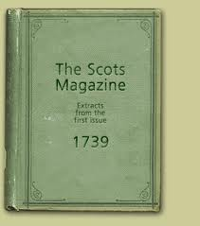
Religious Effects of the Union

The 1712 Toleration Act
- Presbyterians believed that their Church was safe after the Act of Security was passed during the debate on the passage of the Act of Union. Therefore, they initially supported the Union and the Hanoverian Succession.
- Episcopalians and Roman Catholics in the Highlands however, still favoured a return to the Stuart Dynasty.
- In 1712, the British government passed the Toleration Act as a result of the Greenshields Case. James Greenshields was an Episcopalian minister who was put in prison for holding church services in Edinburgh. The House of Lords released him and overturned the Scottish decision.
- This allowed Episcopalianism to be tolerated in Scotland. Many Presbyterians were outraged because they thought this went against the Act of Security and allowed Episcopalianism (very similar to Anglicanism) to flourish.

The 1712 Patronage Act
- This allowed Scottish landowners to appoint ministers in their parish. Presbyterianism said ministers should be chosen by the congregation. This act was therefore viewed as a further breach of the Act of Security.

Presbyterian Divisions
- The Presbyterian Church was also rocked by arguments about Scripture interpretation and whether or not people could change their predestination.

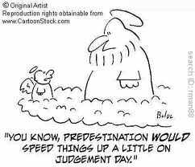

Jacobite Opposition

What did the Jacobites Want?
- The restoration of the Stuart monarchy.
- The Union stated that the Hanoverian succession must be accepted in Scotland. This put an end to any chances of a Stuart becoming monarch again after Anne died.

Who Supported the Jacobites?
- Some people who opposed the Union were prepared to support the Jacobites because they wanted to destroy the Union.
- Lots of Jacobite songs appeared at this time which encouraged supporters.
- Many Scots in the north east and parts of the Highlands supported the cause.
- Some politicians also supported them just in case the Stuarts got back into power – they wanted to make sure their own political careers were safe in this event!

Who did not Support the Jacobites?
- Some Presbyterians. Jacobitism was inextricably linked to Catholicism for them.
- Most Scots in the lowlands did not support the Jacobites.

1708 Attempted Rebellion
- In 1708 the French helped James VII and II’s son James, since known as the Old Pretender, to sail to Scotland to reclaim his throne.
- However, the British Royal Navy and bad weather meant that the invading force could not land their ship.
- They turned back for France.

The 1715 Rebellion
- When George of Hanover became king in 1714, unrest grew in Scotland. There was no longer a Stuart on the throne.
- The Earl of Mar, who was now opposed to the Union having previously supported it (he had lost his office of secretary of state when George became king), organised a gathering of the clans in support of the Jacobite cause in Braemar.
- Mar was hoping for French support.

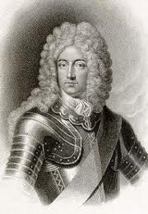
- The Jacobite rebellion was able to grow in strength because there was not a strong British military presence in Scotland. There was also a weapons shortage which made it difficult to arm their supporting lowland Scottish soldiers.
- The Episcopalian church helped spread the Jacobite message and propaganda.
- Many parts of Scotland were suffering economically from the union – this made people more inclined to support the anti-union Jacobites.
- However, the Jacobite cause was dealt a blow when the French changed their foreign policy.
- The War of the Spanish Succession ended with a British victory. Consequently, the French were keen to keep on the good side of Britain and so the French court (under the Duke of Orleans, the regent of Louis XV) withdrew their support from the Jacobites.
- An alliance between France and Britain was finalised in 1717.

The Battle of Sheriffmuir
- This took place in November 1715.
- The Jacobites, under the Earl of Mar met the Government forces led by General John Campbell, the Duke of Argyll.
- The Jacobites withdrew from the fight, but both sides claimed it a victory for them!
- James arrived at Peterhead shortly after.
- He left again in February 1716 when it became clear that the rebellion was running out of steam.

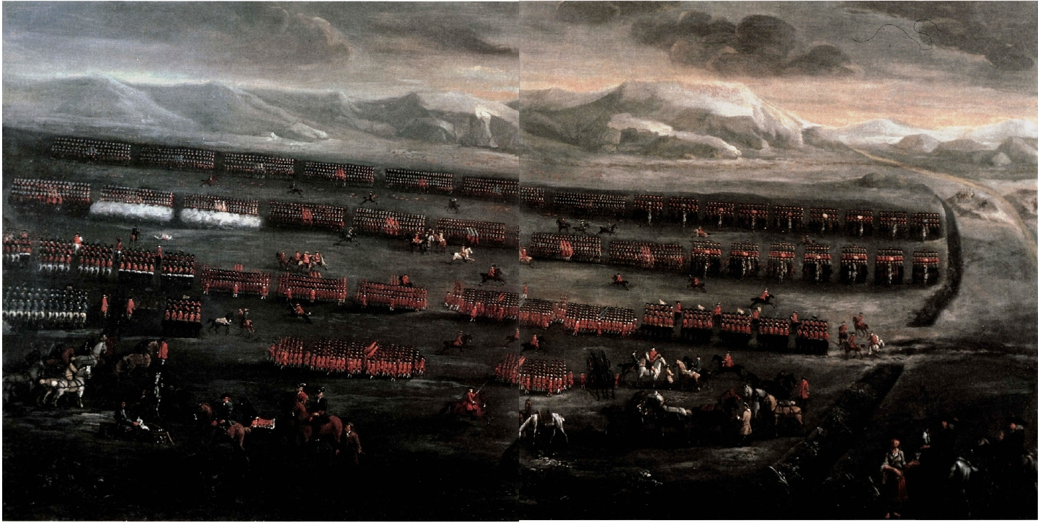
The Battle of Sheriffmuir

The Aftermath of the Rebellion
- Highlanders were no longer allowed to hold weapons under the 1716 Disarming Act.
- A further uprising in 1719 failed.
- Support for the Jacobite cause declined as people began to live with the union and realise that it had benefits too.
- The 1745 uprising led by Bonnie Prince Charlie ended with defeat at Culloden Moor.

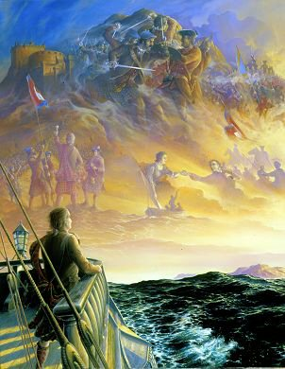

PERSPECTIVE

This is not directly examined.

The 1997 Referendum
- In 1997 there was a referendum which decided that the Scottish Parliament would once again exist.
- However, this time Scotland would still stay in the Union of Great Britain.
- This was the achievement of what Scottish commissars had proposed in 1706 – a partnership of parliaments or a federal union.

Scotland and England 1745-2007
- The Jacobite rebellion led by Bonnie Prince Charlie ended in defeat at Culloden in 1746. Many Jacobite estates were forfeited as a result of the rebellion and the pacification of the Highlands followed.
- During the Enlightenment, many Scottish people contributed to economic and cultural progress. Famous Scots from this time were Adam Smith (an economist), David Hume (a philosopher), Sir Walter Scott (Novelist) and Robert Burns (poet). Many argue that these people could not have achieved such success had the union not happened.
- Many Scots also made revolutionary developments, e.g. The engineer James Watt.
- Robert Owen also established fair treatment for employees in the cotton mill at New Lanark.
- Scotland also played a hugely significant role in the First and Second World Wars. This demonstrated the important of the notion of being British.

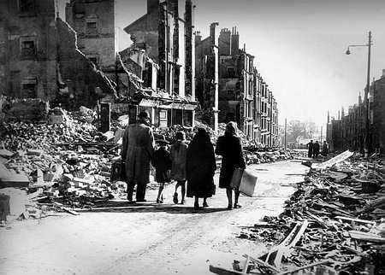
Clydebank during the Blitz

- In 1934 the SNP was formed with the aim of promoting Scottish issues.
- In the 1970s some Scottish people began to favour moves for independence once more. However, many did not want independence and thought that Scotland should remain in the Union.

Devolution
- Devolution meant that Scotland would once again have its own parliament. However, it would have limited powers and Scotland would remain in the Union.
- There was a referendum to decide on Devolution in 1979 but there was not a majority in favour.
- Another referendum was held in 1997 and this time there was a majority.
- The Scottish parliament was re-opened in 1999.
- The SNP won the 2007 election for the first time – 300 years after the Treaty of Union was passed. Many debate whether or not this could lead to independence once more for Scotland.

